Scenario 2: Business Partner & Procure-to-Pay
- SPRO—IMG—CROSS APPLICATIO COMP—SAP BUSINESS PATNER—BUSINESS PATNER—BASIC SETTING—NUMBER RANGE AND GROUPING -ASSIGN NUMBER RANGE AND GROUPING – Define BP group and no. range
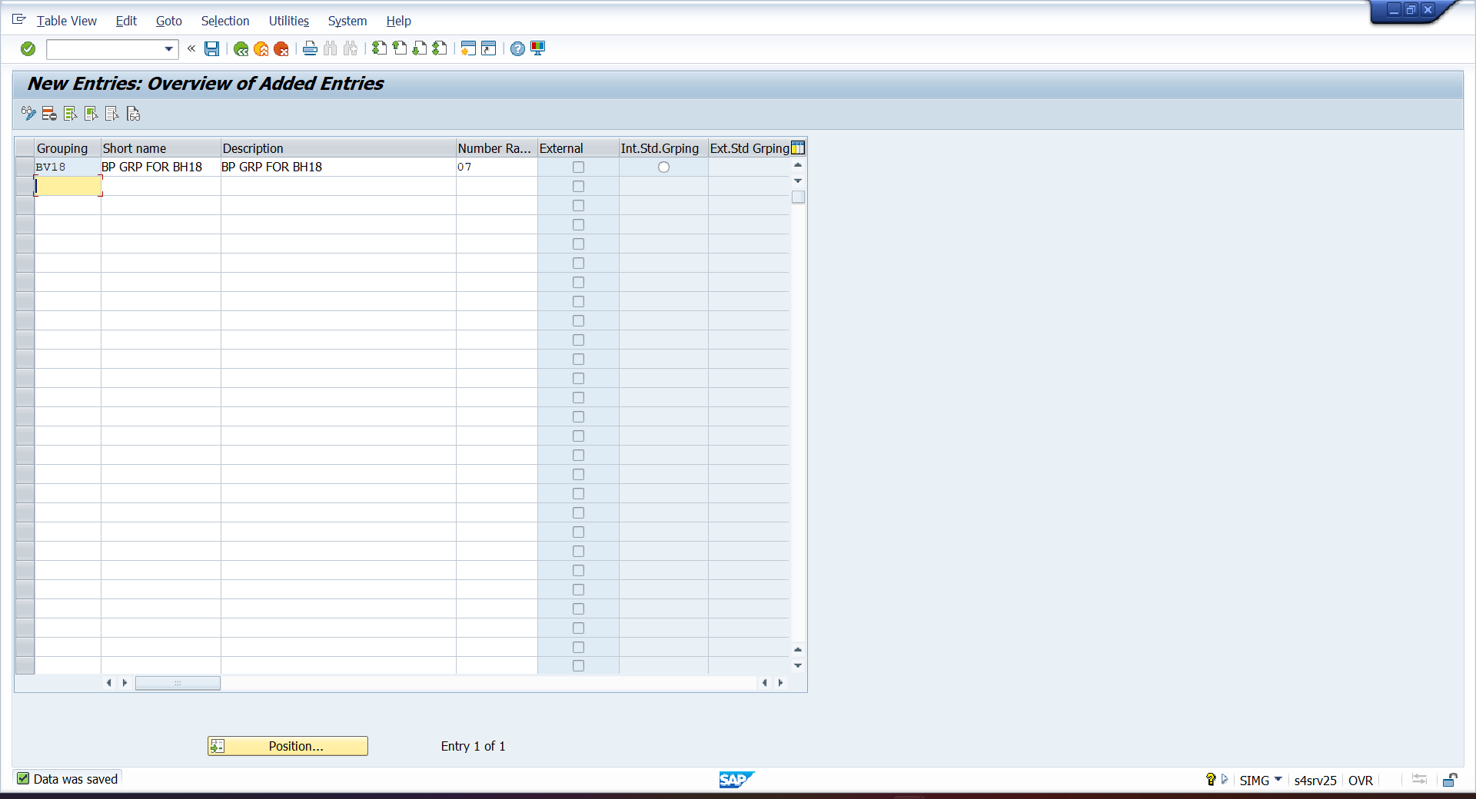

- SPRO—IMG—CROSS APPLICATIO COMP—MASTERDATA SYC—CUTOMER /VENDOR INTEGRAION—BUSINESS PATNER SETTING—SETTING FOR VENDOR INTEGRATION—FIELD ASSIGNMENT VENDOR—ASSIGN KEY—DEFINE NO. ASSIGNMENT FOR BP – Assign vendor group with BP
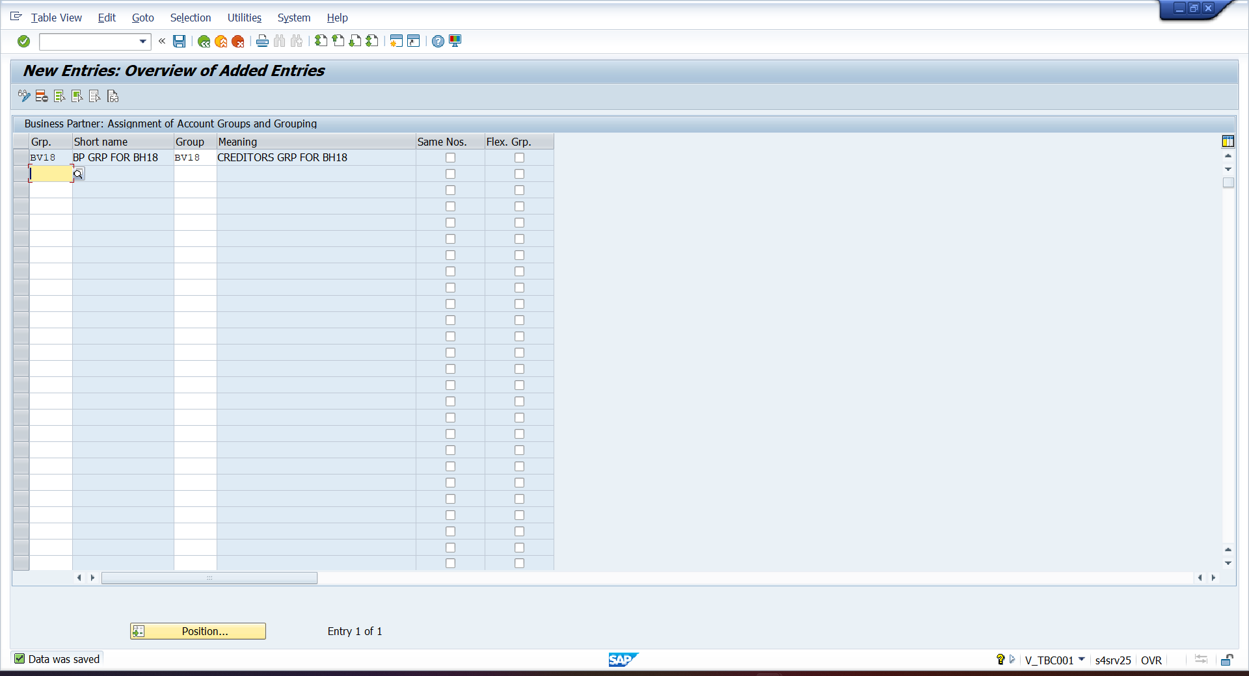
- FS00 – CREATE CREDITORS G/L
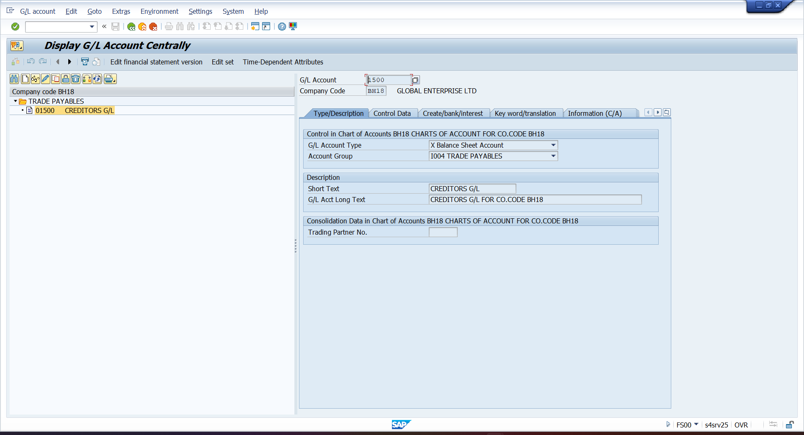

- BP – CREATE BP
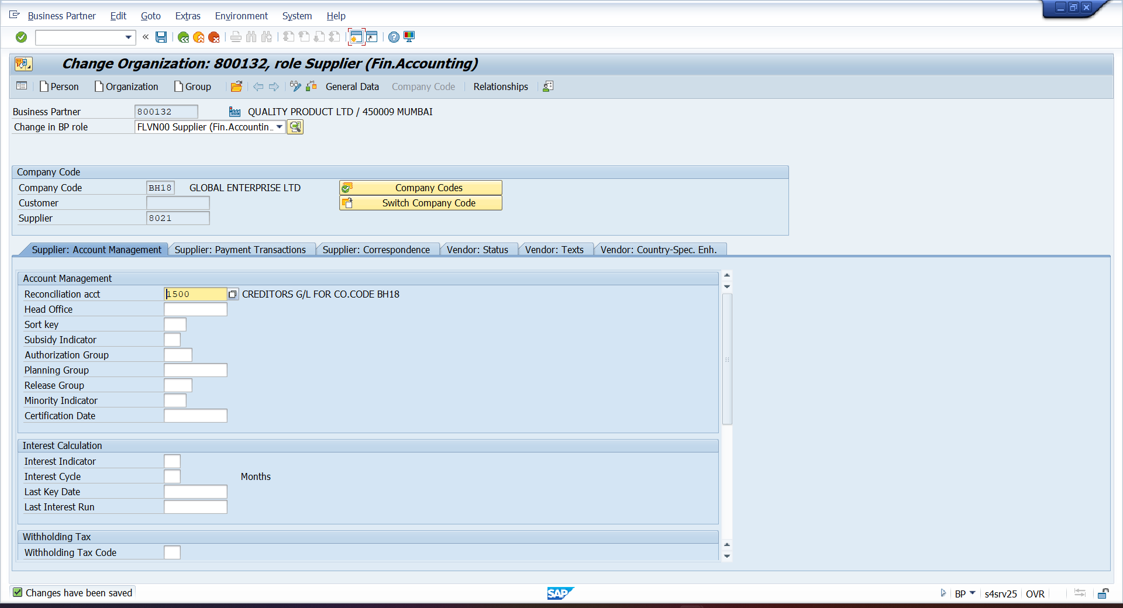

- OBD3 – CREATE VENDORS GROUP
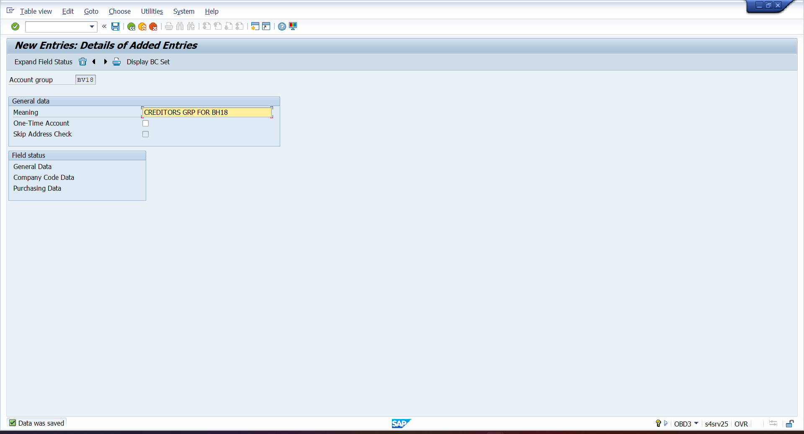

- OBB8 – CREATED PAYMENT TERMS
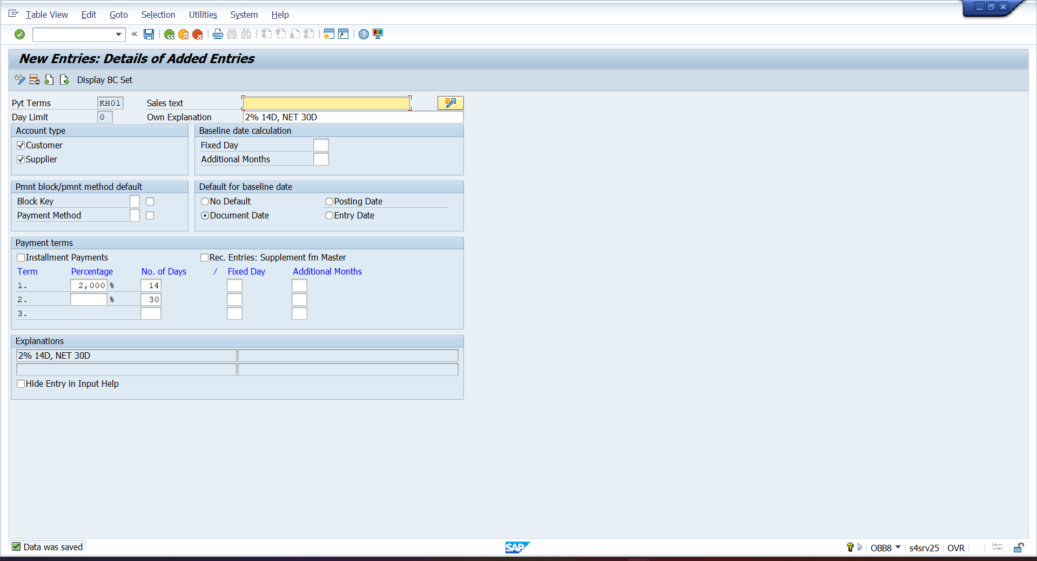

- BP – ASSIGN PAYMENT TERMS TO VENDOR
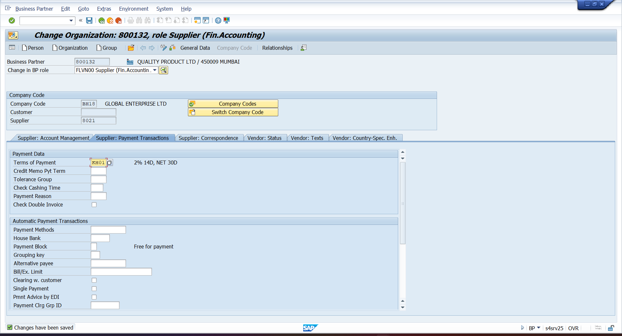
- BP- CREATE VENDOR DISCOUNT G/L
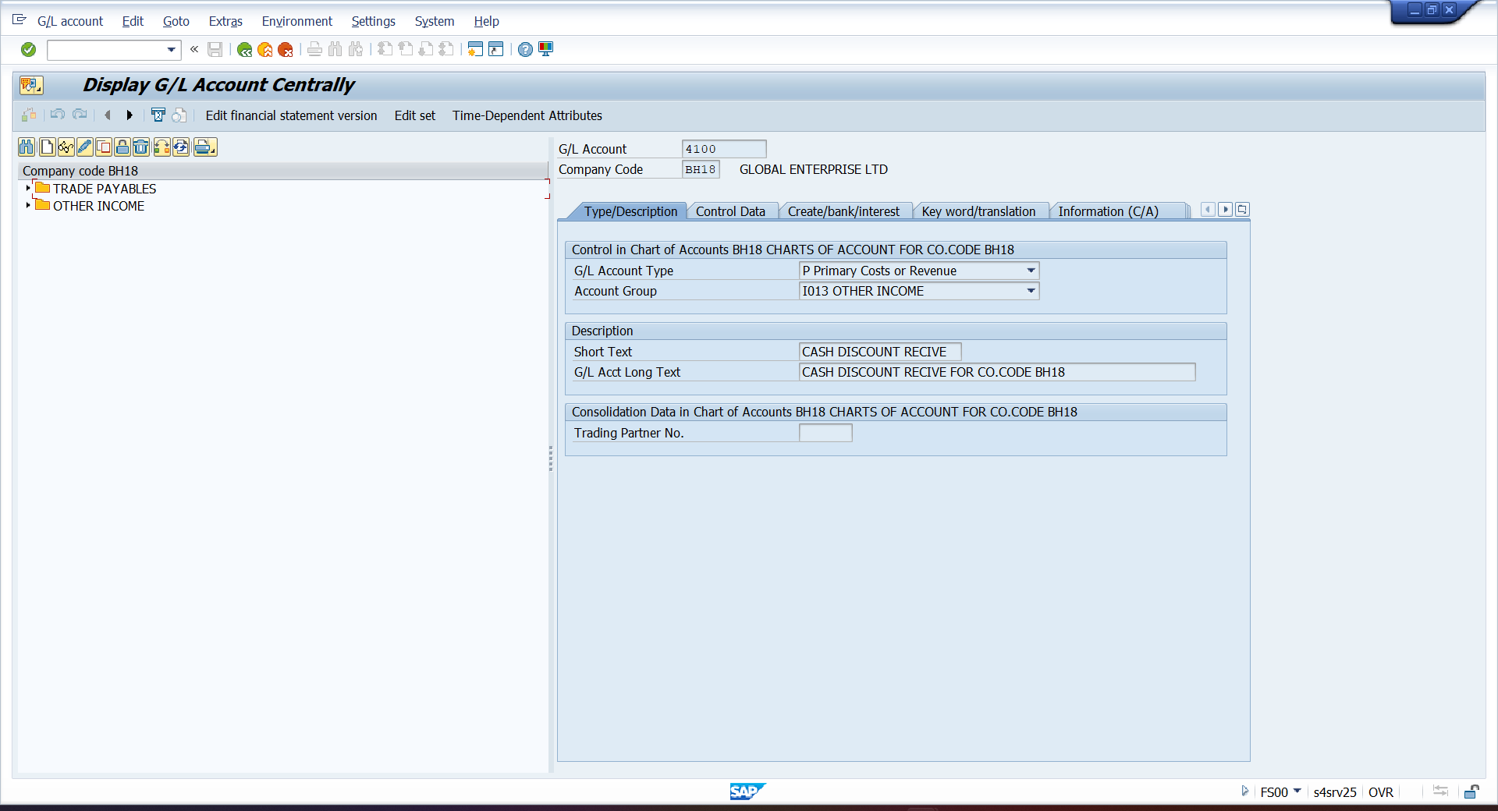

- OBXU – AUTOMATIC A/C DETERMINATION FOR CASH DISCOUNT
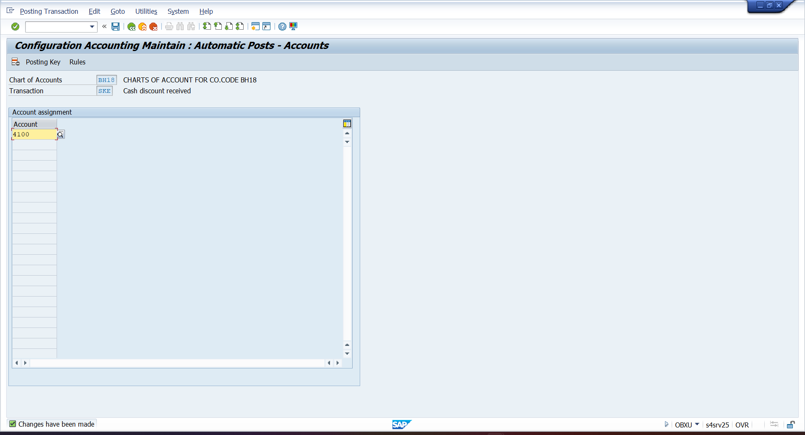

- OBYR- Configure Special G/L Indicator A for Vendor Down Payment
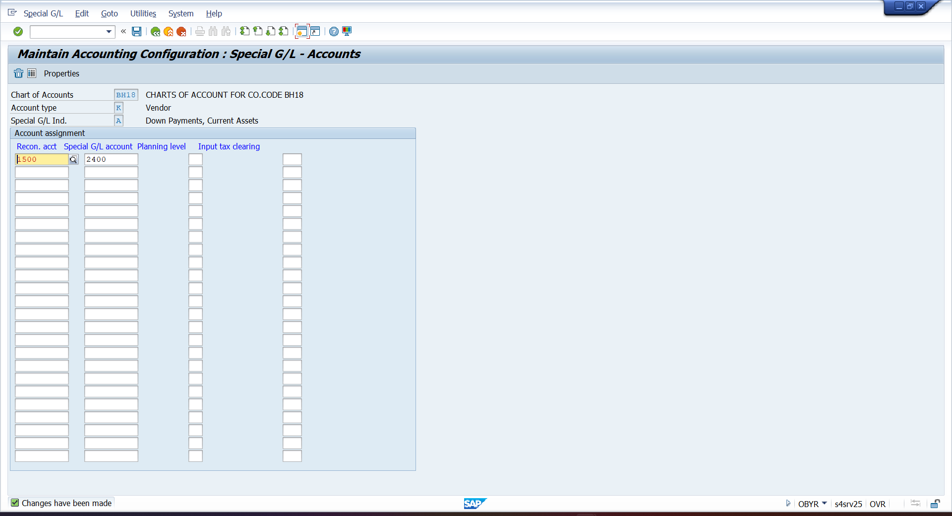

- F-48 – ADVANCE PAYMENT ENTRY
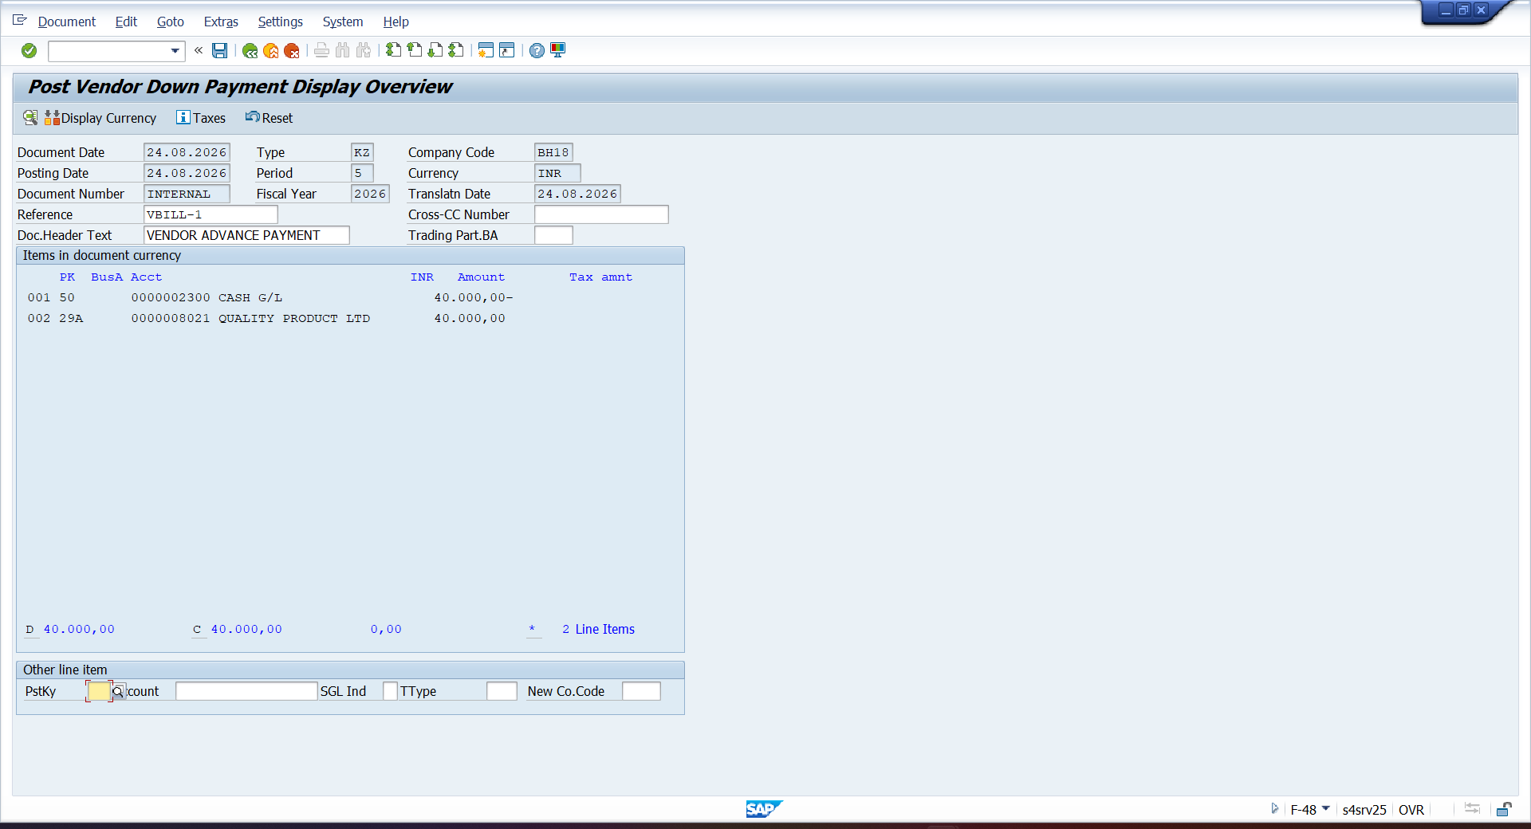

- FB60 – VENDOR INVOICE
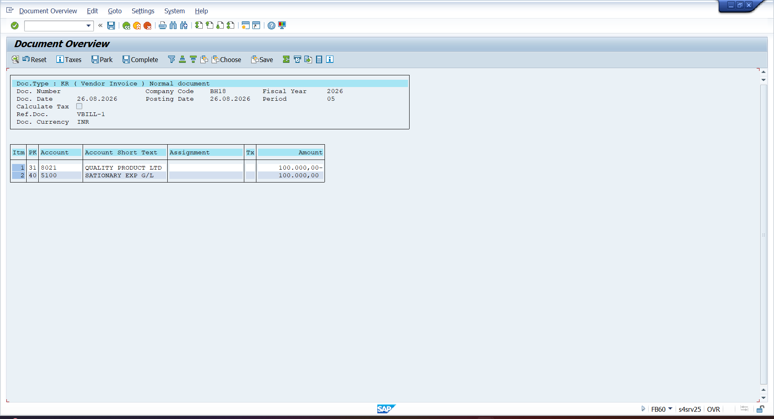

- F-53 – VENDOR PAYMENT INVOICE SETTLE WITH ADVANCE PAYMENT
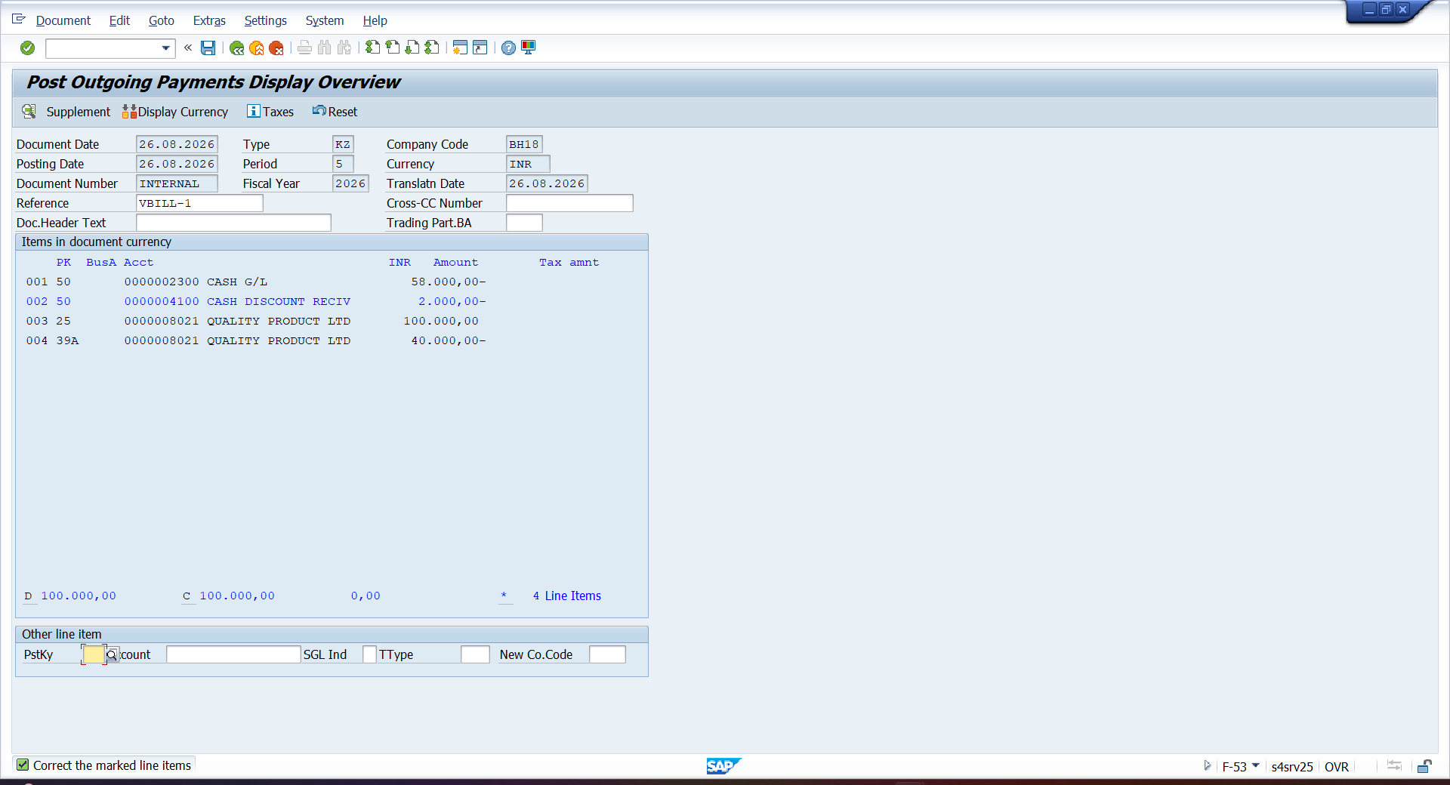

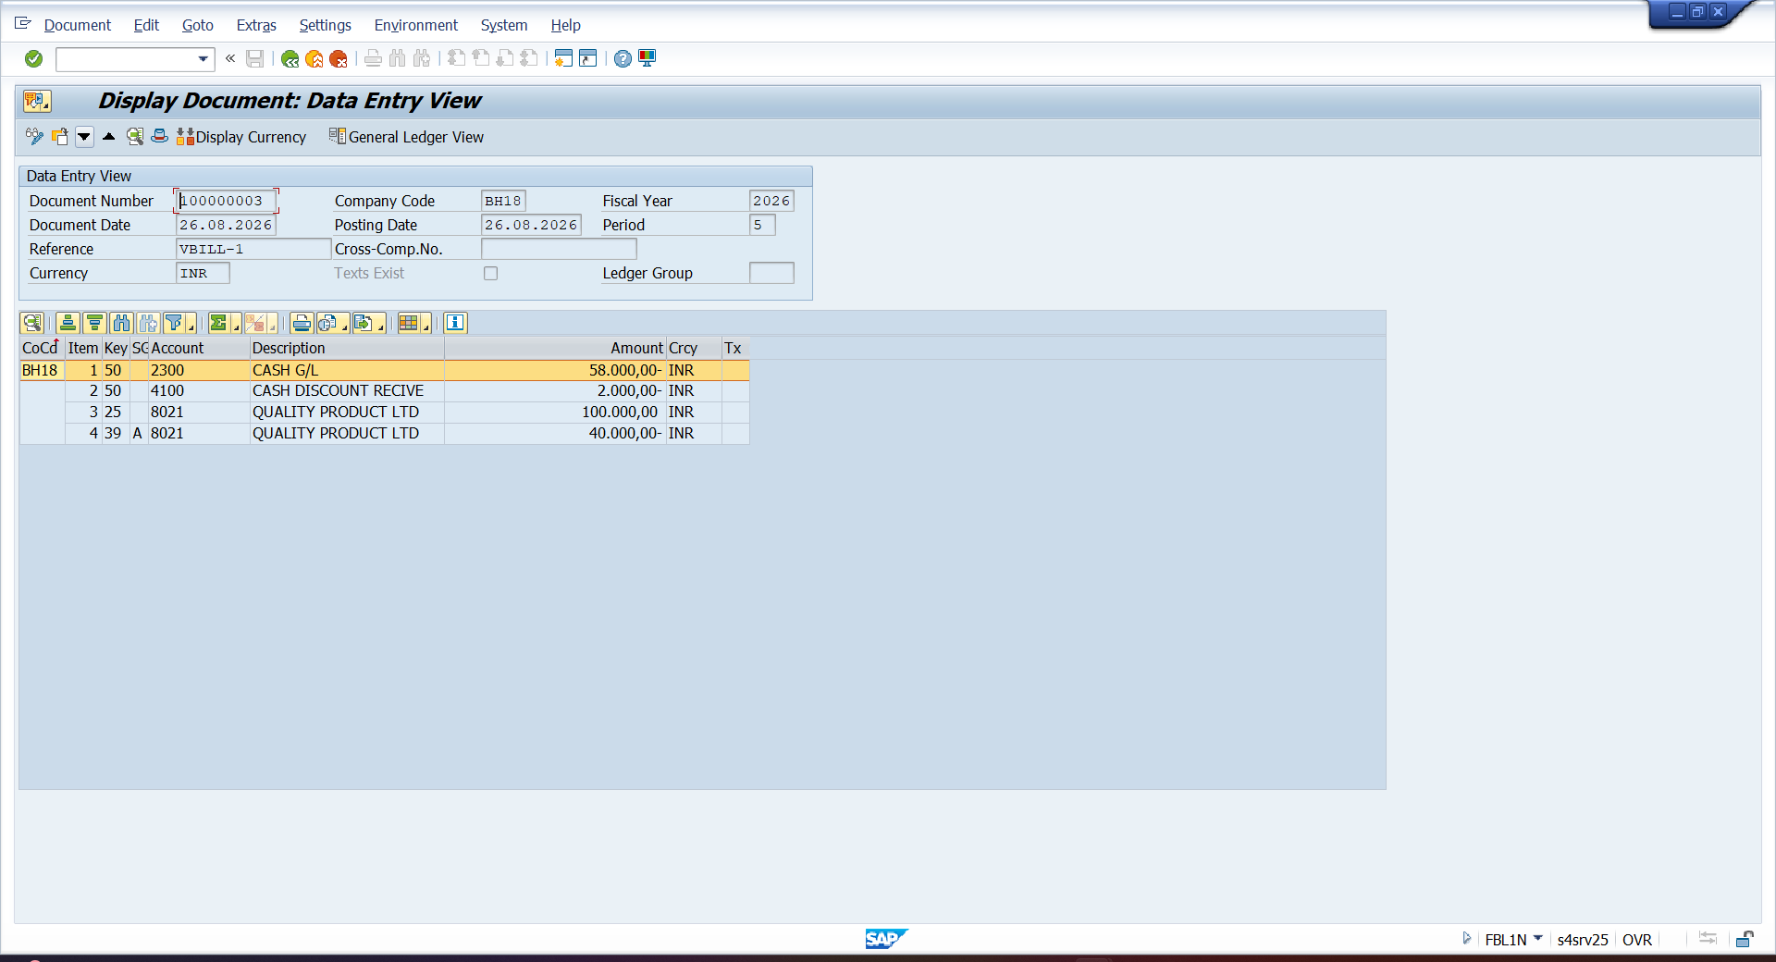
- BP – ASSIGN PURACHASE ORG TO VENDOR
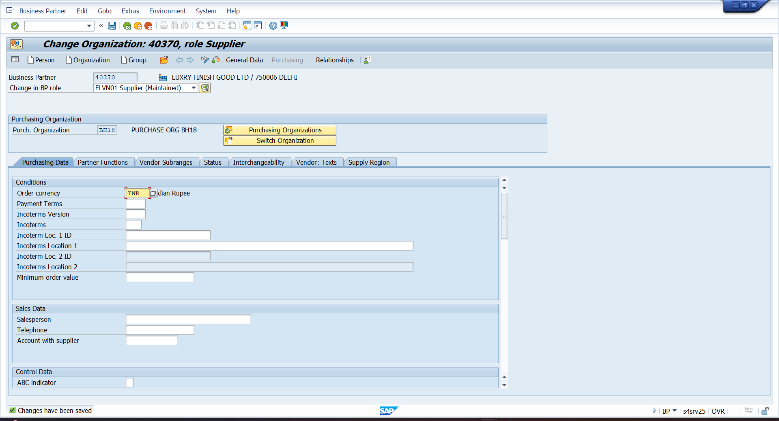

- ME21N – PURCAHSE ORDER
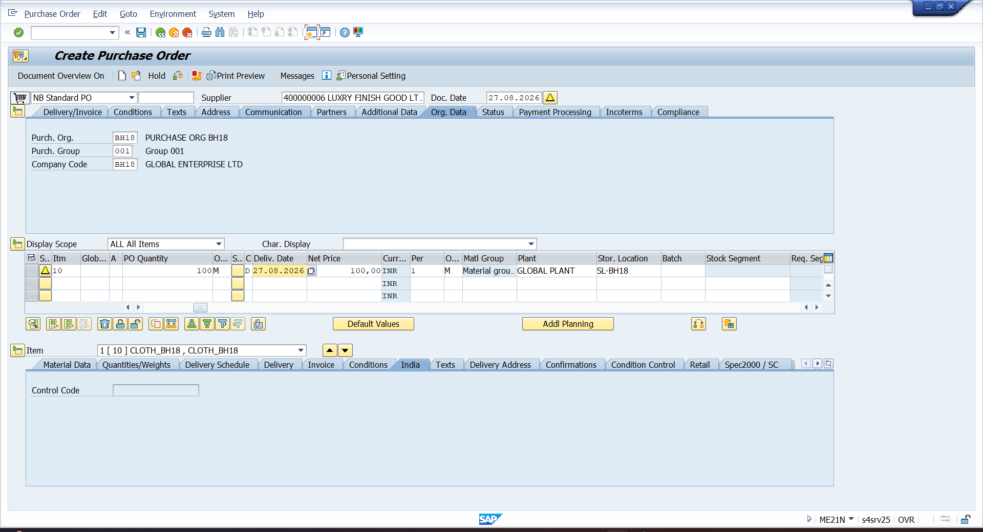

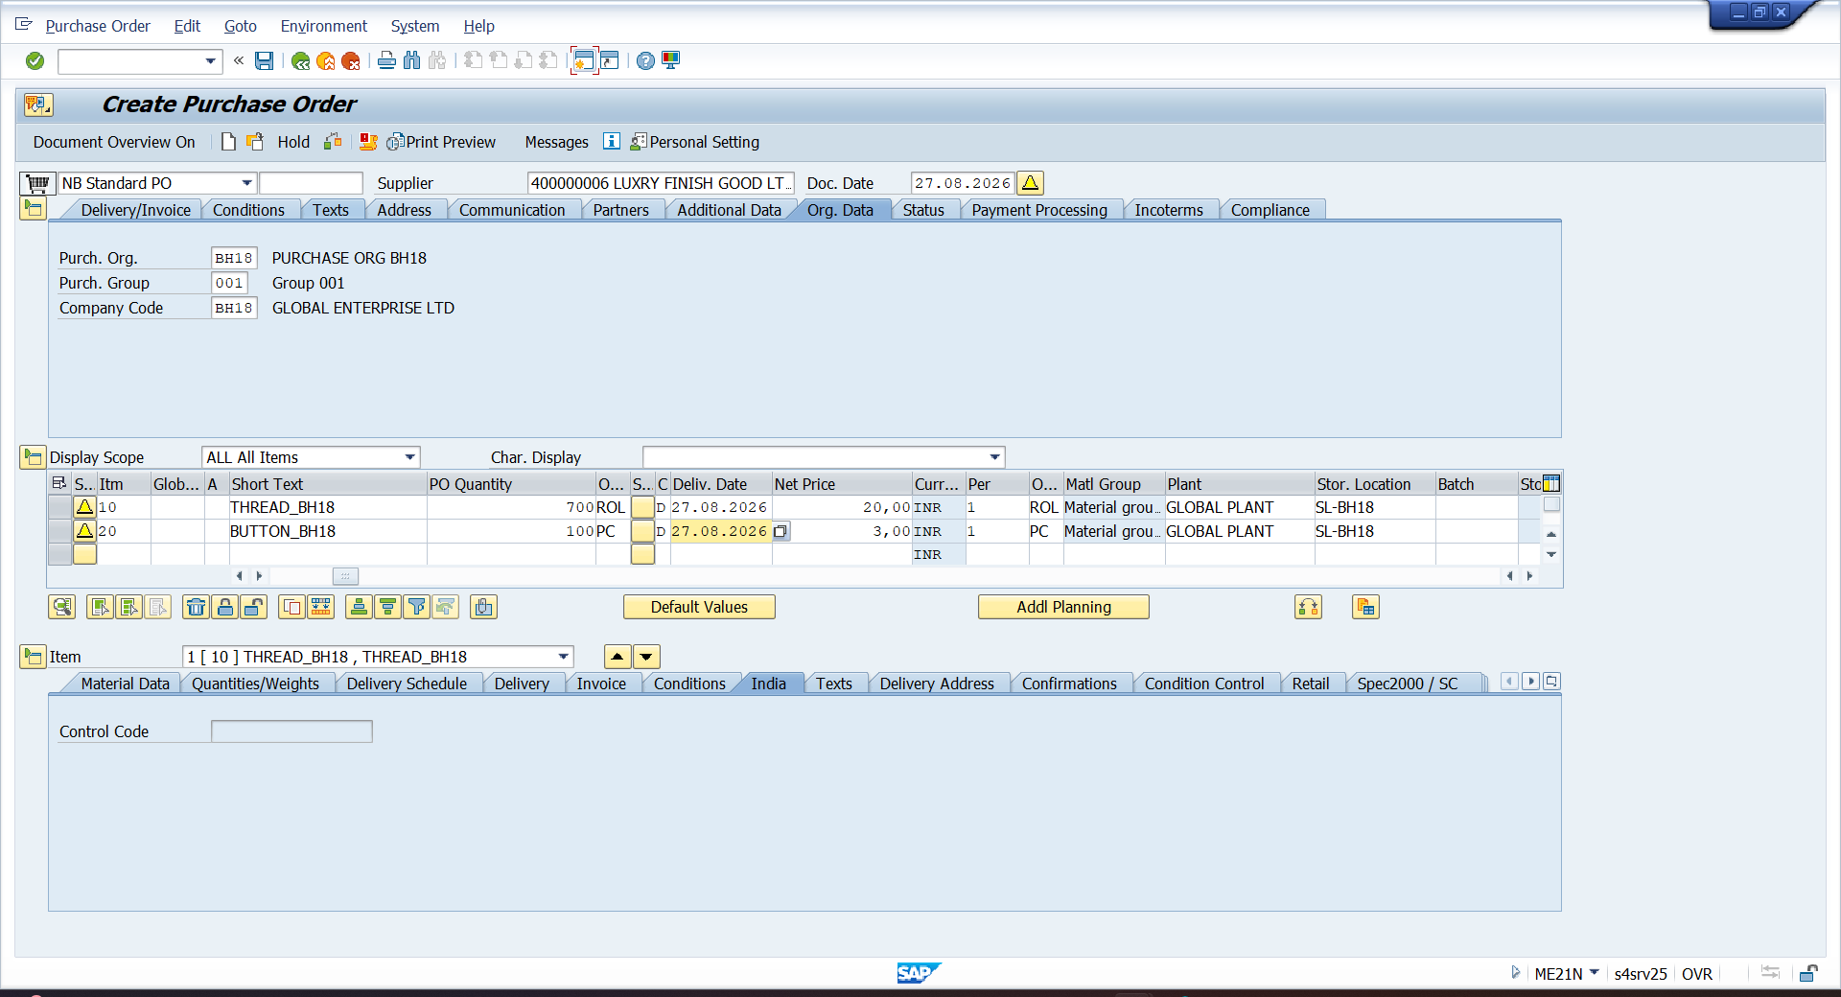

- MIGO – PURCHASE GOODS RECEIPT
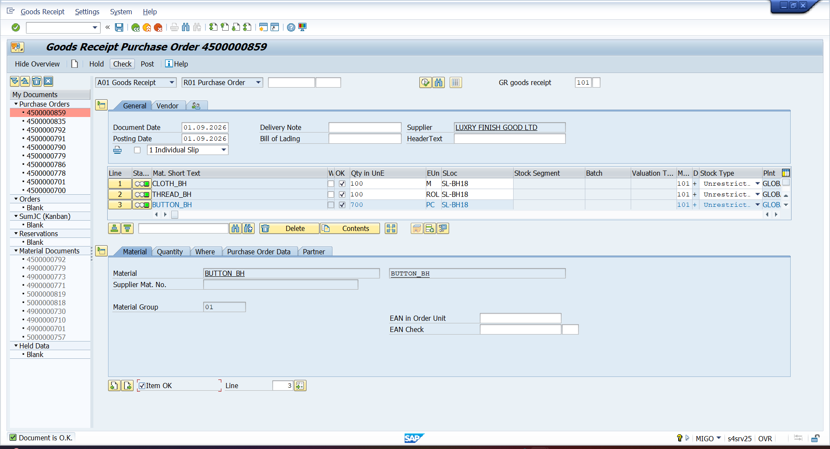

- MB52 – QUANTITY REPORT
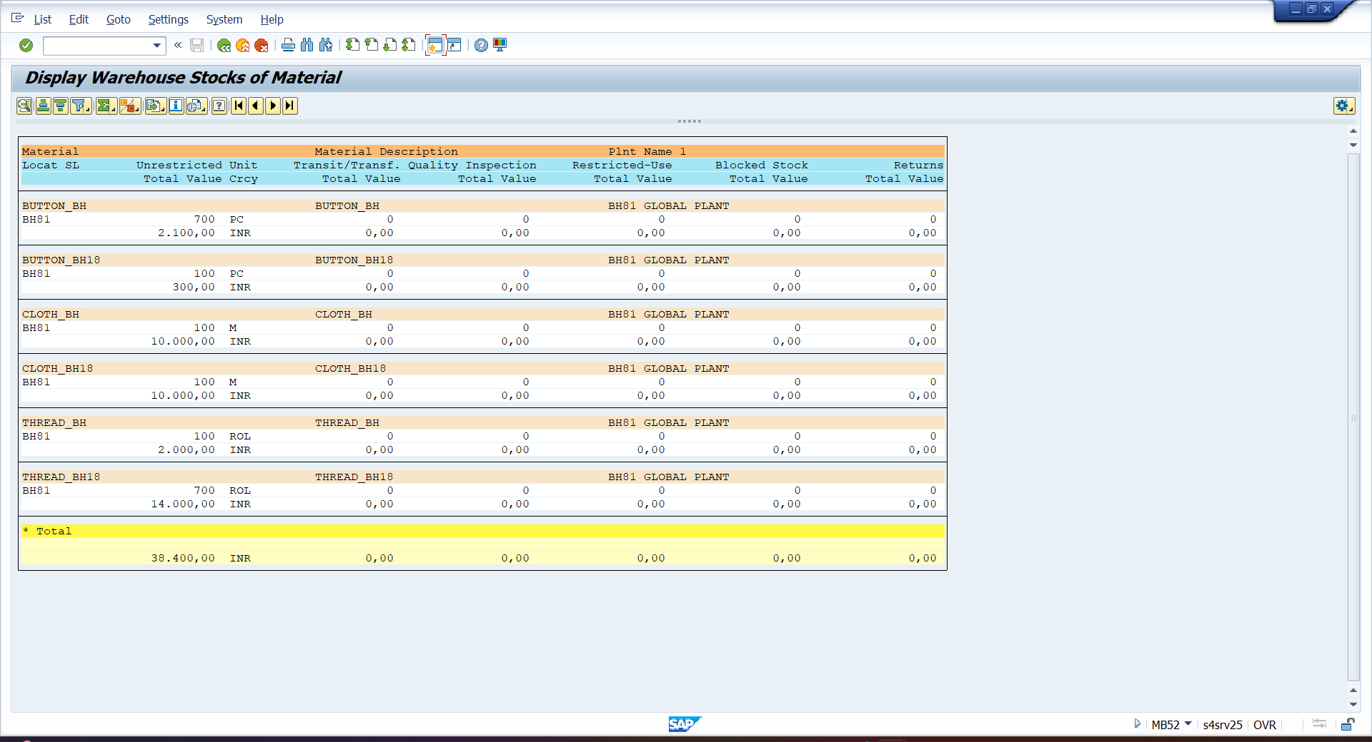

- BUSINESS PLACE
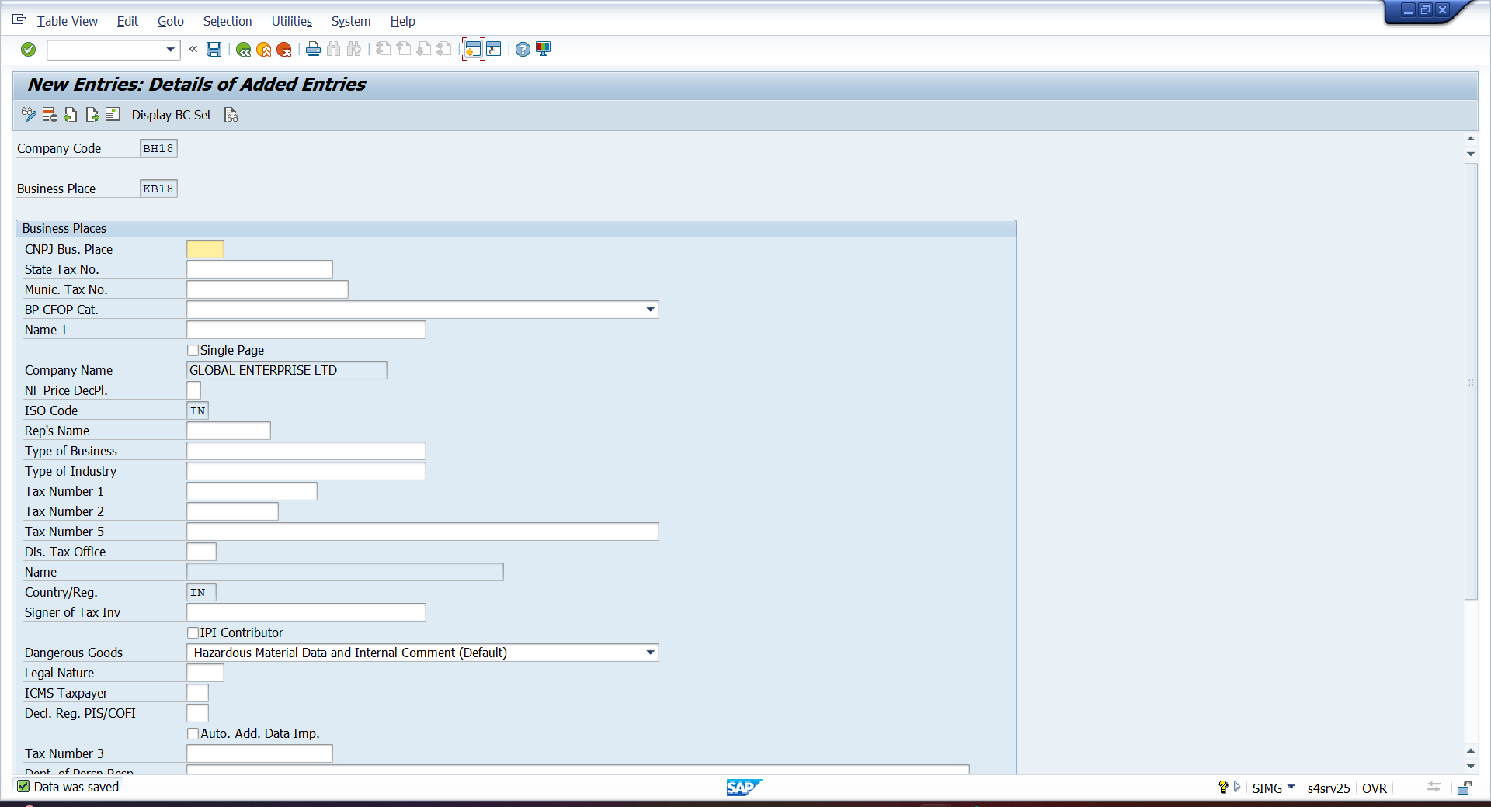
- SECTION CODE
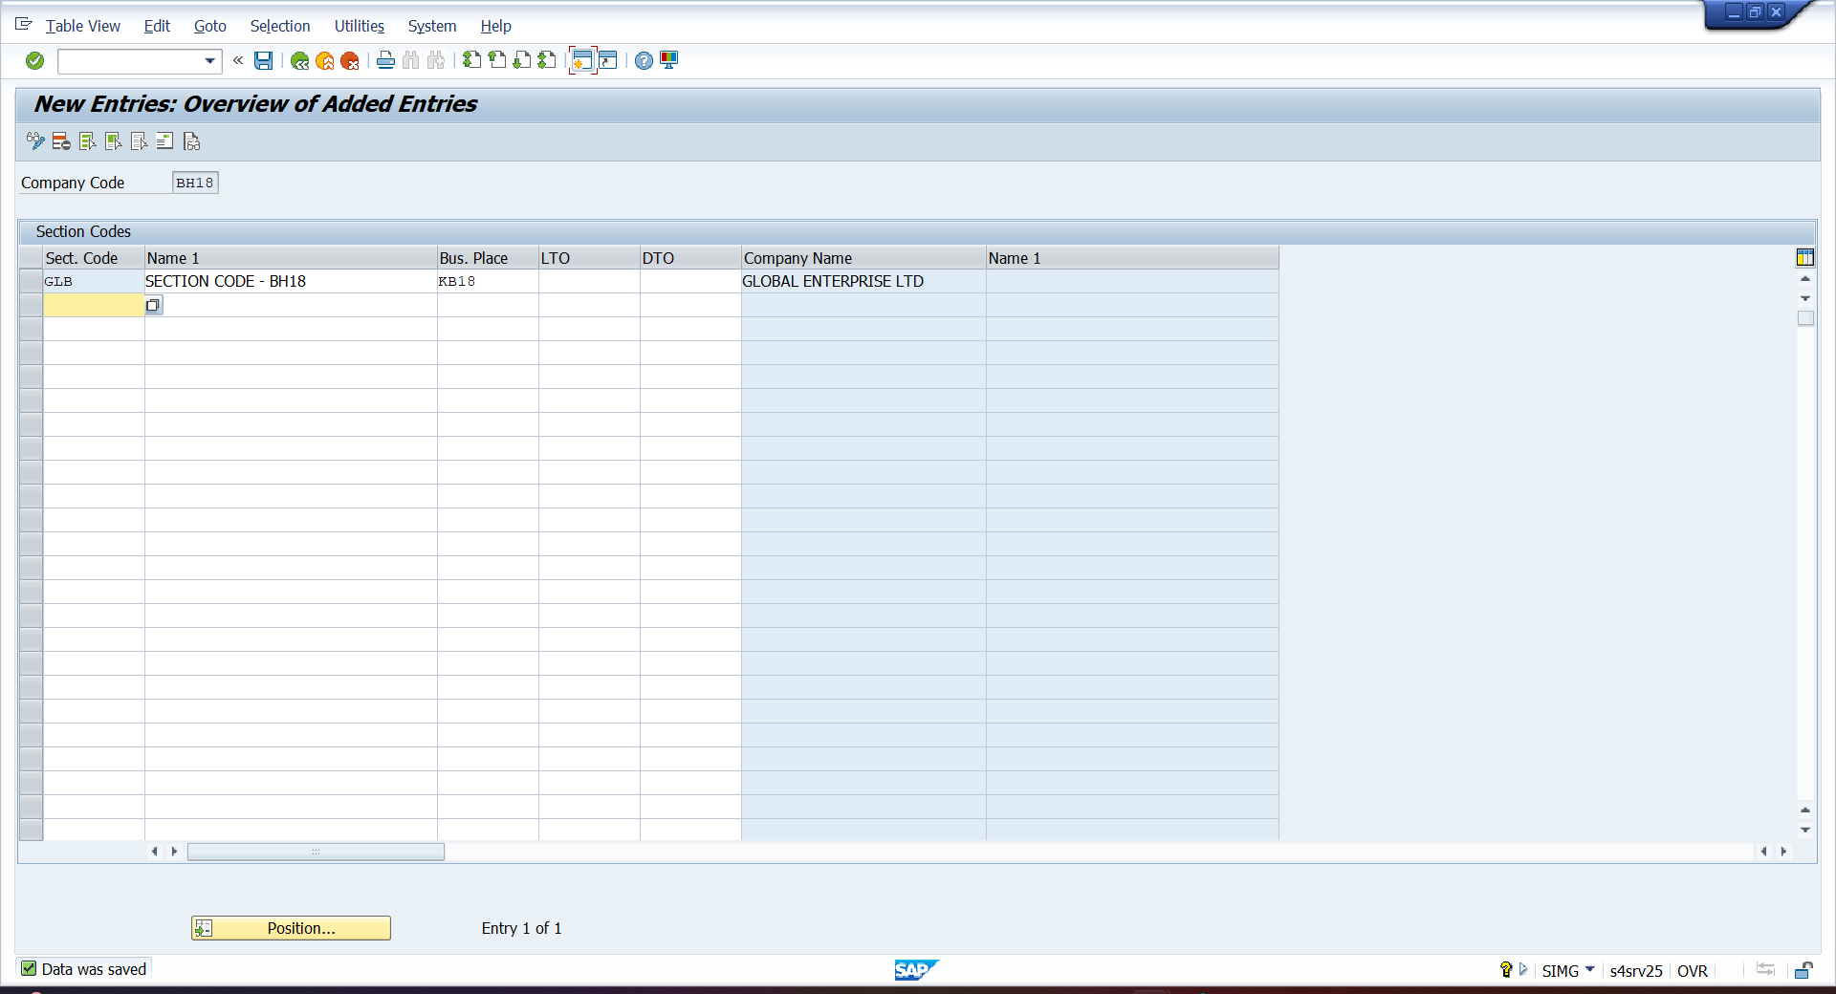

- MIRO – BOOK INVOICE RECEIPT
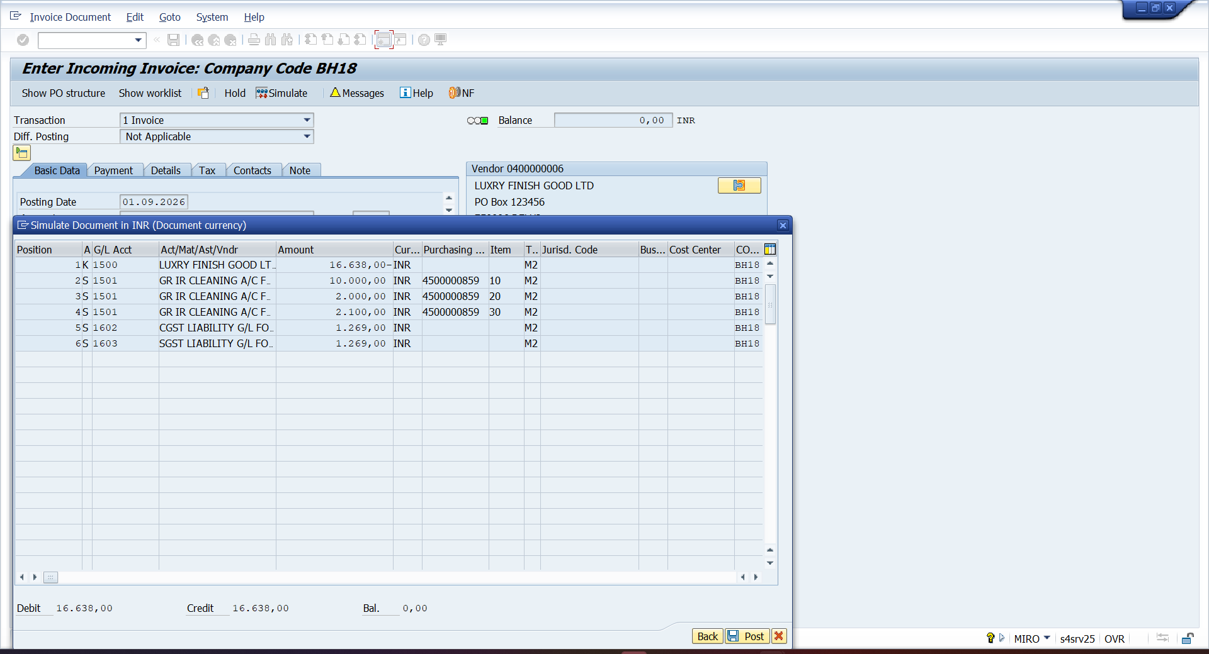

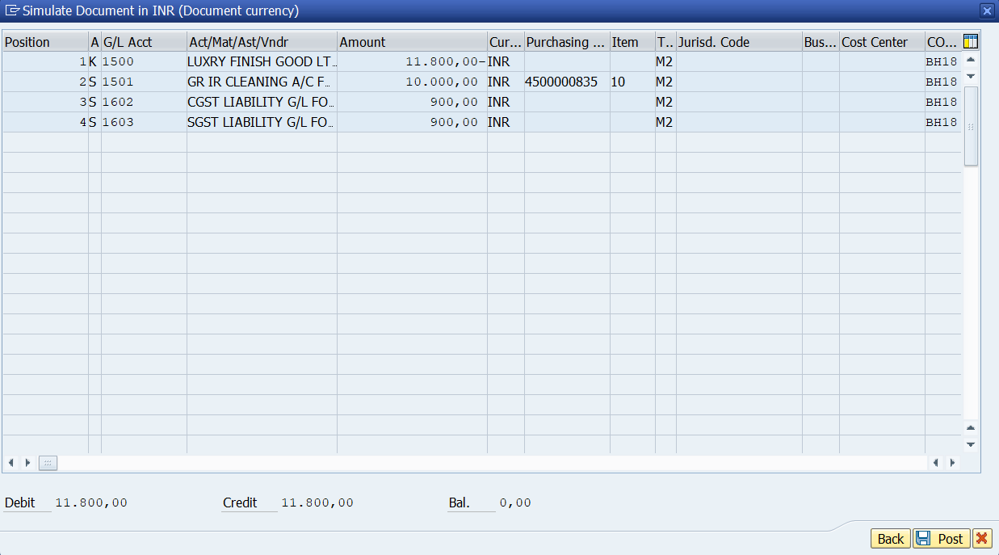

- FBZP – COMPANY CODE
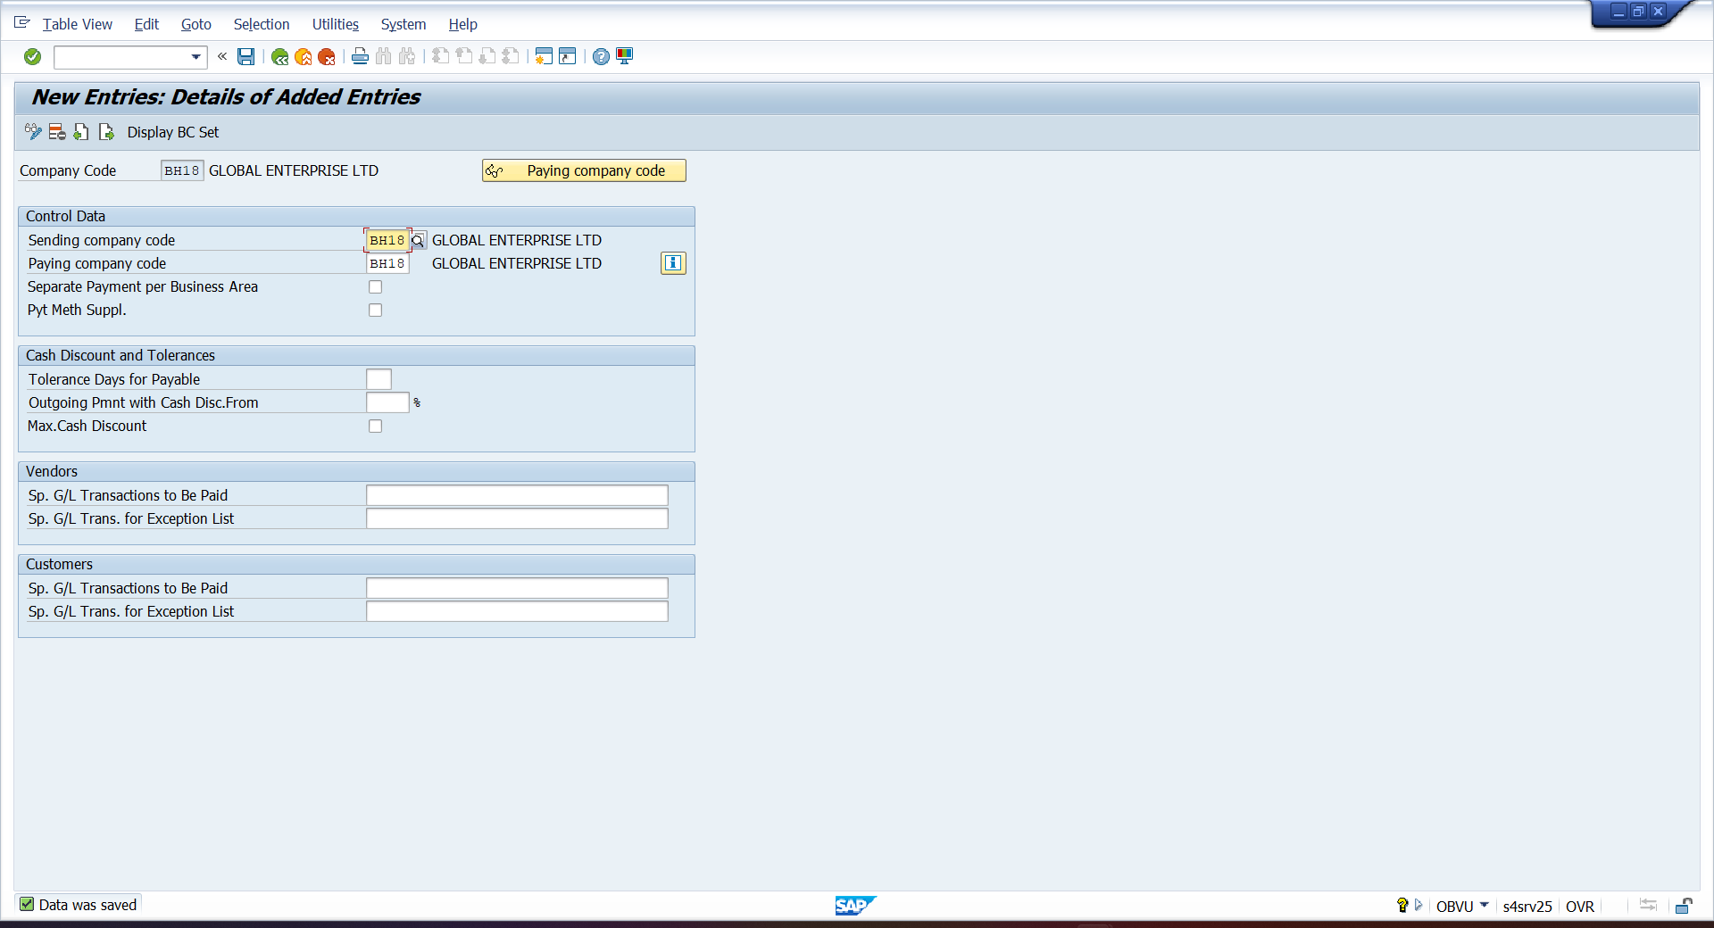

- PAYING CO.CODE
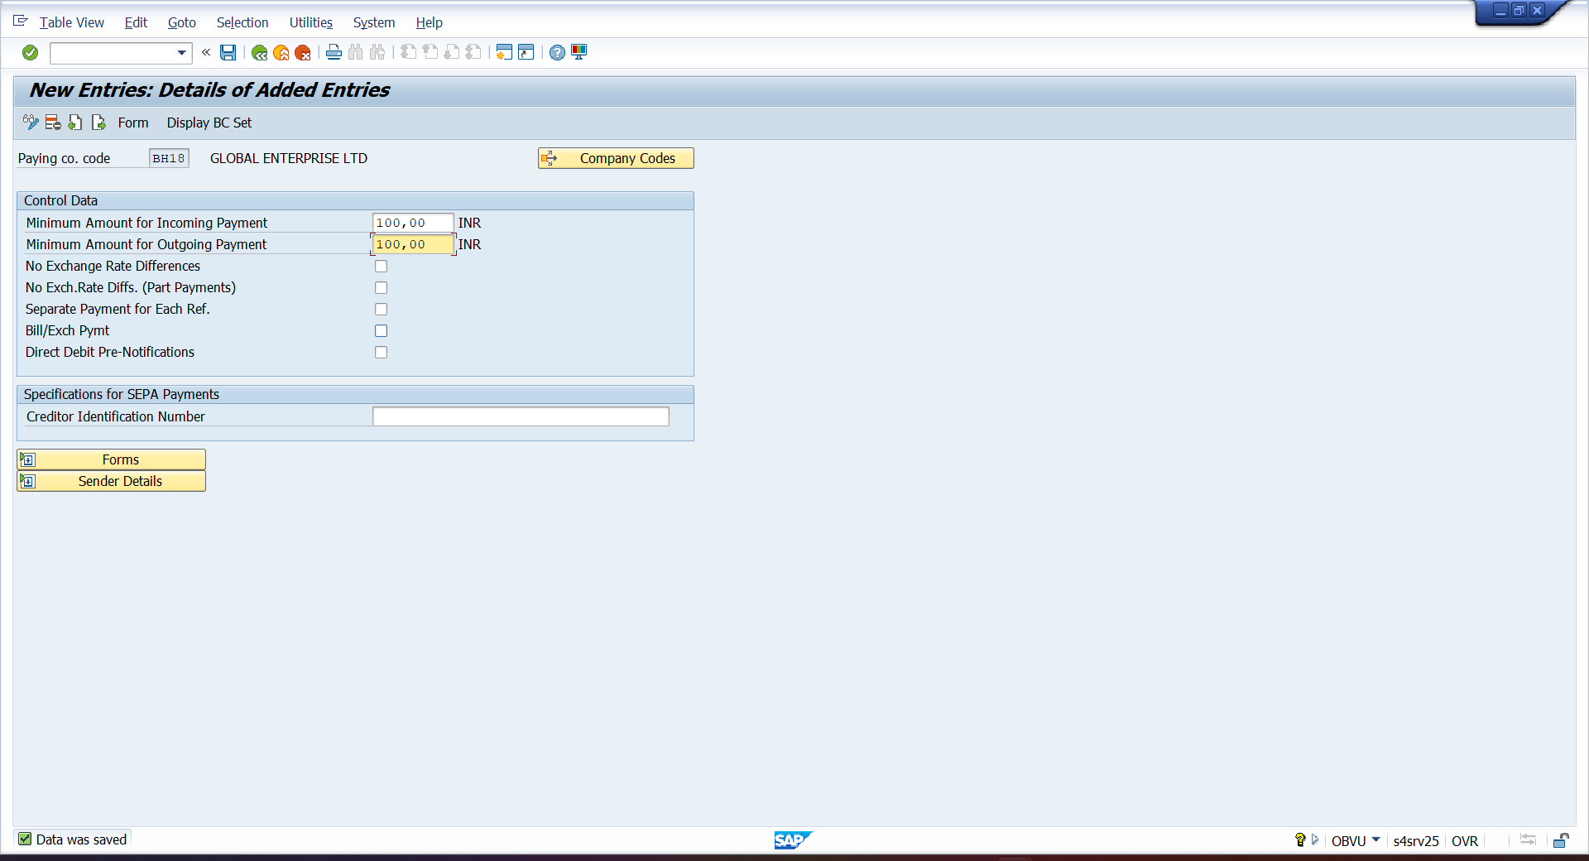

- PAYMENT METHOD IN COUNTRY
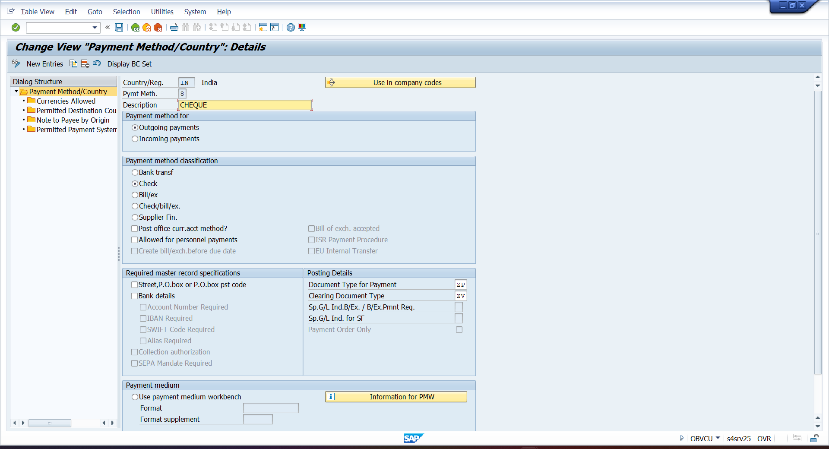
- PAYMENT METHOD IN CO.CODE
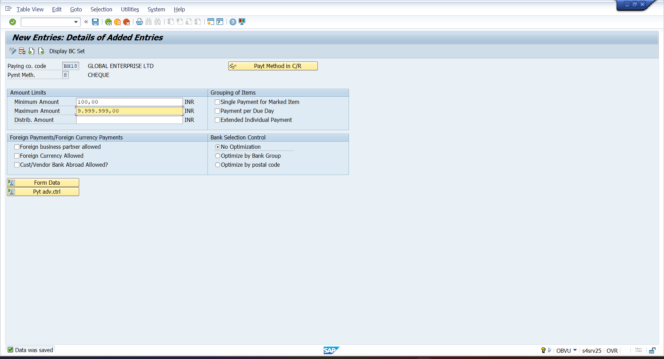

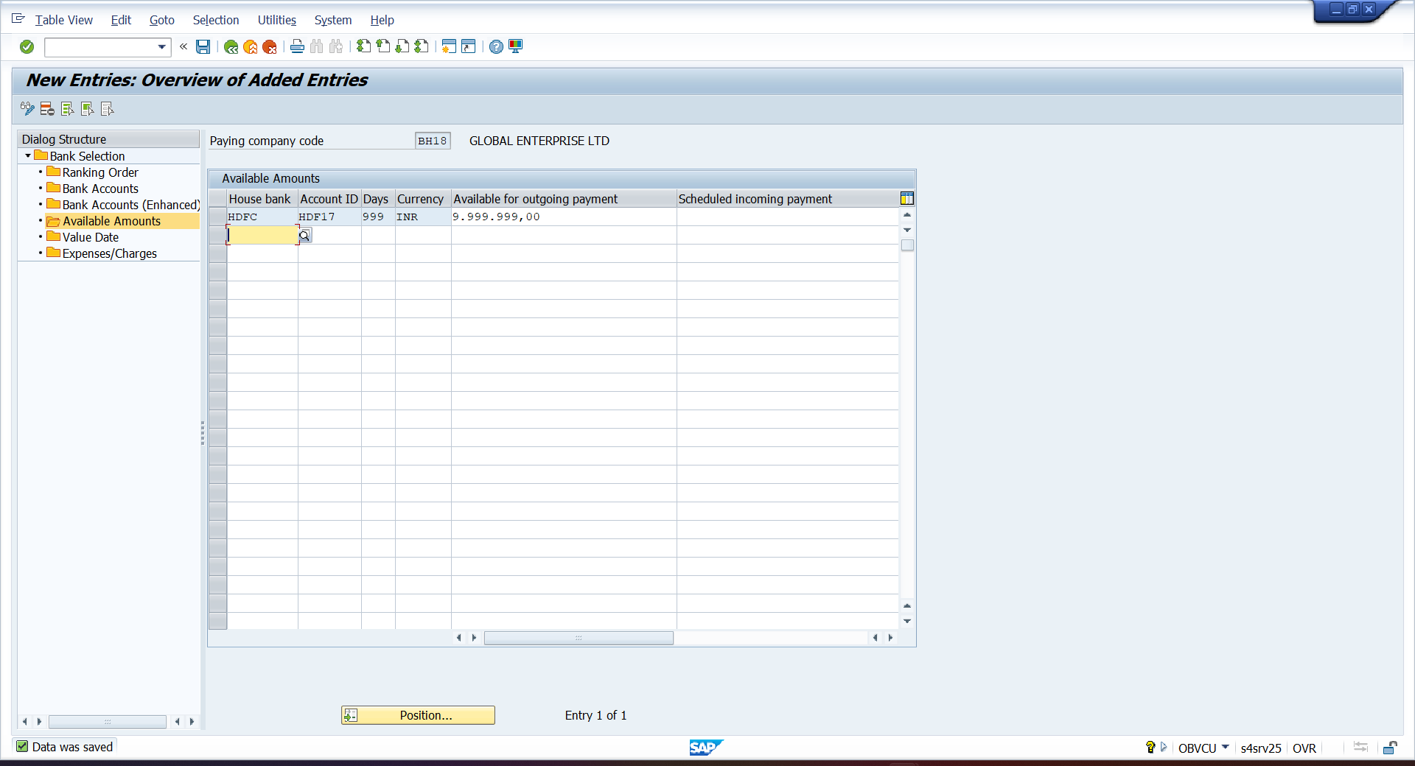
- F110 – RUN AUTOMATIC PAYMENT PROCESS
